Omar Ahmad

EE 180DA

Lab 1A

Week 8 report

This week, I planned to “further develop the program and implement all the character sets we wish to implement” and “change the ‘animation style’ to start and end with complelety black screen and roll the text into the window”

I accomplished both of those tasks. I changed the the program to start from a blank screen and roll the text in. I also implemented 2 new character dictionaries: 6x5 and 5x6. I then implemented a main function to allow anyone to use the program without knowing the ins and outs of the underlying funtions. I also added a time delay in the printing of the pixel data to simulate how the entire block of hats will look when synchronized. This allows one to visualize the text moving across the screen.

The current state of fuctionality is that the program takes in the two dimensions of the block of students, the desired message to display, the sleep delay, and if horizontal orientaion is preferred and produces the pixel data for those selections. There are currently 6 supported configurations: Vertical: 3x5, 4x5, 5x5, & 6x5 and Horizontal: 5x5 & 5x6 (see images below)

   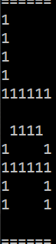 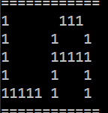 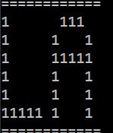

In the next week, I would like to coordinate with my teamates and integrate this program with the communications system they are setting up. I would also like to write the client script that takes in the csv file and a delay time and ouputs the desired on/off of its leds at the correct moment. Finally, if time allows, I would like to test a model of the system and mostly test the synchronization capabilities and how in time we can get the various PIs to be.